Little Miss Colorado presents
LITTLE MISS & mister pueblo
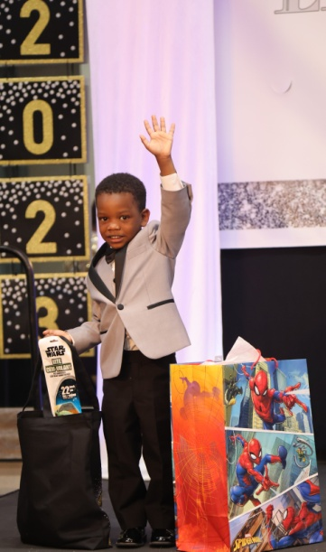
Denim & pearls western pageant

APRIL 15TH
PUEBLO CONVENTION CENTER
$150 entry fee
$200 by deadline

FULL ROUND Crown all!!!!
Easy as 1, 2, 3
1 Beauty
2 Western, diva or denim wear
3 Photo

Register at www.littlemisscolordo.com
Send $100 deposit by 3/24/23 via PayPal to beauty@littlemisscolorado.com
Grand supreme Titles
Glitz natural mister miss/ms elite
Ultimate ultimate ultimate ultimate
Grand grand grand grand
Supreme supreme supreme supreme

Grand grand grand grand
Supreme supreme supreme supreme
0-6years 7 & up 0-6 years 7 & up
Star grand supreme super star grand supreme
Mini mini mini mini
Grand grand grand grand
Supreme supreme supreme supreme
0-4 years 0-4 years 0-4 years 0-4 years
Overall supreme Titles
Overall beauty supreme/ most handsome supreme
Overall personality supreme
Overall photo supreme
Overall model supreme
Divisional supreme Titles
Divisional supreme queen
Divisional beauty supreme
Other titles
Princess
Age divisions
0-23months/2years/3-4/5-6/7-9/10-12/13-15/16-18/elite 19 +
Mandatory fee
Entry fee $200
Includes beauty, western/denim/diva wear & photo

Adult armband $20

Child armband 2-12 yrs $10

Optional fees

Extra ooc $25
Replacement score for western wear, best score goes into supreme score

Extra photo $5ea

Unlimited photos $25

Door jackpots $25ea
Face/personality/photo/outfit of choice

Divisional optional $25

Grand talent $25

STAR GRAND SUPREME $25
Not double crownable. Beauty and photo score combined. This
Title is pulled after Ultimate and Grand and before mini grand.

SUPER STAR GRAND SUPREME $25
Not double crownable. Personality and model score combined. This Title is pulled after Ultimate and Grand and before mini grand.

Little miss pueblo schedule

Saturday, ARPIL 15TH

Early Registration Friday night
Late Registration 0-6 6am-8:30
Late Registration 7 & up 10am-1:30
MORNING EVENTS
Boys /0-23M Beauty 9am
2 YEAR OLD BEAUTY 9:15
3-4 Beauty 9:30
5-6 BEAUTY 9:45
Boys /0-23M DENIM/PEARL/WESTRN 10AM
2 YEAR OLD DENIM/PEARL/WESTERN 10:15
3-4 DENIM/PEARL/WESTERN 10:30
5-6 DENIM PEARL/WESTERN 10:45
Boys /0-23M SPRING WEAR 11am
2 YEAR OLD SPRING WEAR 11:15
3-4 SPRING WEAR 11:30
5-6 SPRING WEAR 11:45
BOYS/0-2 Extra OOC/TALENT noon
3-6 YEAR OLD Extra OOC/TALENT 12:15
LUNCH BREAK 12:30pm-1pm
Little miss pueblo schedule

AFTERNOON EVENTS

7-9 Beauty 1Pm
10-12 YEAR OLD BEAUTY 1:15
TEEN Beauty 1:30
ELITE BEAUTY 1:45
7-9 DENIM/PEARL/WESTRN 2PM
10-12 DENIM/PEARL/WESTERN 2:15
TEEN DENIM/PEARL/WESTERN 2:30
ELITE DENIM PEARL/WESTERN 2:45
7-9 SPRING WEAR 3PM
10-12 SPRING WEAR 3:15
TEEN SPRING WEAR 3:30
ELITE SPRING WEAR 3:45
7-12 EXTRA OOC/talent 4PM
Teen/elite EXTRA OOC/talent 4:15
EXTRA OOC/talent 4:30
EXTRA OOC/talent 4:45
TABULATION 5PM
BALLROOM MUST BE CLEARED FOR TABLULATION
CROWNING 6:30pm
ALL EVENT TIMES ARE LINE UP TIMES. YOU MUST BE READY TO GO ON STAGE WITH NUMBER BY LINE UP TIME OR POINTS WIL BE DEDUCTED.

